Factors contributing to antibiotic misuse among parents of school‑going children in Dhaka City, Bangladesh

| **Characteristic** | **N = 705***1* |
| --- | --- |
| Parent’s age (years) |  |
| < 25 | 13 (1.8%) |
| > 45 | 47 (6.7%) |
| 25–35 | 377 (54%) |
| 36–45 | 267 (38%) |
| Unknown | 1 |
| Parent’s sex |  |
| Female | 551 (78%) |
| Male | 153 (22%) |
| Unknown | 1 |
| Parent’s education level |  |
| Postgraduate | 175 (25%) |
| Primary | 35 (5.0%) |
| Secondary | 381 (54%) |
| Undergraduate | 113 (16%) |
| Unknown | 1 |
| Employment status |  |
| Employed | 95 (13%) |
| Not employed | 503 (71%) |
| Self employed | 106 (15%) |
| Unknown | 1 |
| Family type |  |
| Extended family | 147 (21%) |
| Nuclear family | 372 (53%) |
| Single parent family | 185 (26%) |
| Unknown | 1 |
| Your average household income per month (BDT) |  |
| High (greater than 50000 BDT) | 139 (20%) |
| Low (less than 30000 BDT) | 160 (23%) |
| Middle (less than 50000 BDT) | 405 (58%) |
| Unknown | 1 |
| Child’s sex |  |
| Female | 379 (54%) |
| Male | 325 (46%) |
| Unknown | 1 |
| Child’s age (years) |  |
| < 5 | 37 (5.3%) |
| > 10 | 313 (45%) |
| 5–9 | 353 (50%) |
| Unknown | 2 |
| Number of children |  |
| >= 3 | 104 (15%) |
| 1 | 176 (25%) |
| 2 | 424 (60%) |
| Unknown | 1 |
| Who is the leading child caregiver at home? |  |
| Father | 54 (7.7%) |
| Grandmother | 16 (2.3%) |
| Mother | 629 (89%) |
| Others | 5 (0.7%) |
| Unknown | 1 |
| Are grandparents at home involved in treatment decisions when your child is ill? |  |
| Always | 34 (4.8%) |
| Never | 459 (65%) |
| Often | 54 (7.7%) |
| Sometimes | 157 (22%) |
| Unknown | 1 |
|  | |

Table 1. Demographic characteristics of study participants (N = 705)

The survey had 704 respondents in total, 153 (22%) of whom were men and 551 (78%) of whom were women. The ages of the parents were divided into four groups: under 25, 25–35, 36–45, and over 45 years old (corresponding to 1.8%, 54%, 38%, and 6.7%, respectively). Parents' educational backgrounds varied; the majority (54%), postgraduate (25%), undergraduate (16%), and elementary (5%) were among the highest percentages had completed higher secondary education. Of the participants, 13% were employed. Of the participants, single-parent families (26%) and extended families (21%). The majority of participants (53) belonged to nuclear families. 54% of the total respondents had female children; the remaining research participants had male children; 60% of parents had only two children, 25% had only one, and 15% had more than two. About 89% of parents stated that the mother was the child's primary carer at home. Regarding the management of their child's illness, 65% of parents claimed that their grandparents were not involved in decision-making, while 35% said that they were involved in treatment decisions.

| **Characteristic** | **N = 705***1* |
| --- | --- |
| Information provided by pharmaceutical companies leaflet | 78 (11%) |
| Unknown | 1 |
| Information from prescribers | 607 (86%) |
| Unknown | 1 |
| Information from dispensers | 252 (36%) |
| Unknown | 1 |
| Information from nurses | 22 (3.1%) |
| Unknown | 1 |
| Information given by a colleague | 34 (4.8%) |
| Unknown | 1 |
| Information from University courses | 16 (2.3%) |
| Unknown | 1 |
| Internet | 213 (30%) |
| Unknown | 1 |
| Social media | 165 (23%) |
| Unknown | 1 |
| Others...56 | 89 (13%) |
| Unknown | 1 |
|  | |

**Table 2.** Major sources of information about antibiotic parents (N = 705).

Prescribers (86%), dispensers (36%) and the Internet (30%) were the main sources of information for parents. Parents rarely learnt about antibiotics from academic courses, pharmaceutical companies (11%) or other sources (23%) such as coworkers and nurses. Instead, most parents learnt about antibiotics from social media (23%).

| **Characteristic** | **N = 705***1* |
| --- | --- |
| Knowledge_level |  |
| Good | 92 (13%) |
| Moderate | 419 (59%) |
| Poor | 194 (28%) |
| Attitude_level |  |
| Good | 490 (70%) |
| Moderate | 187 (27%) |
| Poor | 27 (3.8%) |
| Unknown | 1 |
| Practice_level |  |
| Good | 577 (82%) |
| misuse | 127 (18%) |
| Unknown | 1 |
| **Table 3**. Level of knowledge, attitudes, and practices towards antibiotic resistance among parents with school going children (N = 704)  The overall level of knowledge, attitudes, and practices regarding the sensible use of antibiotics in children. Of the 705 parents evaluated using the KAP, 13% (n = 92) had good knowledge, 59% (n = 419) had moderate, 70% (n = 490) had a positive attitude, and 82% (n = 577) had good practices for rational antibiotic use in children. | |
| | **Characteristic** | **N** | **OR***1* | **95% CI***1* | **p-value** | | --- | --- | --- | --- | --- | | Parent’s age (years) | 704 |  |  | **<0.001** | | < 25 |  | — | — |  | | > 45 |  | 0.23 | 0.07, 0.76 |  | | 25–35 |  | 0.37 | 0.12, 1.07 |  | | 36–45 |  | 0.21 | 0.07, 0.60 |  | | Parent’s sex | 704 |  |  | **<0.001** | | Female |  | — | — |  | | Male |  | 0.49 | 0.34, 0.71 |  | | Parent’s education level | 704 |  |  | **<0.001** | | Postgraduate |  | — | — |  | | Primary |  | 10.8 | 5.12, 23.3 |  | | Secondary |  | 3.62 | 2.47, 5.33 |  | | Undergraduate |  | 1.77 | 1.09, 2.88 |  | | Employment status | 704 |  |  | **<0.001** | | Employed |  | — | — |  | | Not employed |  | 2.75 | 1.75, 4.37 |  | | Self employed |  | 1.04 | 0.59, 1.82 |  | | Family type | 704 |  |  | 0.6 | | Extended family |  | — | — |  | | Nuclear family |  | 1.07 | 0.73, 1.56 |  | | Single parent family |  | 1.25 | 0.81, 1.93 |  | | Your average household income per month (BDT) | 704 |  |  | **<0.001** | | High (greater than 50000 BDT) |  | — | — |  | | Low (less than 30000 BDT) |  | 3.64 | 2.29, 5.81 |  | | Middle (less than 50000 BDT) |  | 1.61 | 1.08, 2.39 |  | | Child’s sex | 704 |  |  | 0.2 | | Female |  | — | — |  | | Male |  | 0.83 | 0.62, 1.11 |  | | Child’s age (years) | 703 |  |  | **0.077** | | < 5 |  | — | — |  | | > 10 |  | 2.19 | 1.10, 4.36 |  | | 5–9 |  | 2.12 | 1.07, 4.19 |  | | Number of children | 704 |  |  | 0.5 | | >= 3 |  | — | — |  | | 1 |  | 1.02 | 0.63, 1.64 |  | | 2 |  | 0.85 | 0.56, 1.30 |  | | *1*OR = Odds Ratio, CI = Confidence Interval | | | | |   **Table 4.** Factors associated with the level of knowledge among parents of school-going children (N = 704). OR odds ratio, CI confidence interval. *p-value ˂ 0.05 was considered statistically significant. Significant values are in bold. | |

| **Characteristic** | **N** | **OR***1* | **95% CI***1* | **p-value** |
| --- | --- | --- | --- | --- |
| Parent’s age (years) | 704 |  |  | 0.66 |
| < 25 |  | — | — |  |
| > 45 |  | 1.61 | 0.35, 11.5 |  |
| 25–35 |  | 2.11 | 0.54, 13.9 |  |
| 36–45 |  | 2.01 | 0.51, 13.3 |  |
| Parent’s sex | 704 |  |  | 0.33 |
| Female |  | — | — |  |
| Male |  | 0.82 | 0.55, 1.21 |  |
| Parent’s education level | 704 |  |  | **<0.001** |
| Postgraduate |  | — | — |  |
| Primary |  | 4.84 | 2.29, 10.2 |  |
| Secondary |  | 2.81 | 1.82, 4.44 |  |
| Undergraduate |  | 1.41 | 0.78, 2.53 |  |
| Employment status | 704 |  |  | 0.31 |
| Employed |  | — | — |  |
| Not employed |  | 1.12 | 0.70, 1.86 |  |
| Self employed |  | 1.52 | 0.84, 2.77 |  |
| Family type | 704 |  |  | **<0.001** |
| Extended family |  | — | — |  |
| Nuclear family |  | 2.38 | 1.52, 3.83 |  |
| Single parent family |  | 1.74 | 1.04, 2.96 |  |
| Your average household income per month (BDT) | 704 |  |  | **<0.001** |
| High (greater than 50000 BDT) |  | — | — |  |
| Low (less than 30000 BDT) |  | 3.07 | 1.84, 5.27 |  |
| Middle (less than 50000 BDT) |  | 1.86 | 1.17, 3.04 |  |
| Child’s sex | 704 |  |  | 0.78 |
| Female |  | — | — |  |
| Male |  | 1.05 | 0.76, 1.44 |  |
| Child’s age (years) | 703 |  |  | 0.24 |
| < 5 |  | — | — |  |
| > 10 |  | 1.04 | 0.50, 2.32 |  |
| 5–9 |  | 1.36 | 0.66, 3.02 |  |
| Number of children | 704 |  |  | 0.25 |
| >= 3 |  | — | — |  |
| 1 |  | 1.41 | 0.84, 2.40 |  |
| 2 |  | 1.05 | 0.66, 1.70 |  |
| *1*OR = Odds Ratio, CI = Confidence Interval | | | | |

**Table 5.** Factors associated with the level of attitudes towards antibiotic resistance among parents of school going children (N = 704). OR odds ratio, CI confidence interval. *p-value ˂ 0.05 was considered statistically significant. Significant values are in bold.

| **Characteristic** | **N** | **OR***1* | **95% CI***1* | **p-value** |
| --- | --- | --- | --- | --- |
| Parent’s age (years) | 704 |  |  |  |
| < 25 |  | — | — |  |
| > 45 |  | 0.90 | 0.22, 4.57 | 0.9 |
| 25–35 |  | 0.51 | 0.15, 2.33 | 0.3 |
| 36–45 |  | 1.05 | 0.31, 4.79 | >0.9 |
| Parent’s sex | 704 |  |  |  |
| Female |  | — | — |  |
| Male |  | 1.41 | 0.90, 2.17 | 0.13 |
| Parent’s education level | 704 |  |  |  |
| Postgraduate |  | — | — |  |
| Primary |  | 8.31 | 3.45, 20.4 | <0.001 |
| Secondary |  | 3.21 | 1.79, 6.20 | <0.001 |
| Undergraduate |  | 3.01 | 1.47, 6.42 | 0.003 |
| Employment status | 704 |  |  |  |
| Employed |  | — | — |  |
| Not employed |  | 0.68 | 0.40, 1.18 | 0.2 |
| Self employed |  | 1.09 | 0.56, 2.12 | 0.8 |
| Family type | 704 |  |  |  |
| Extended family |  | — | — |  |
| Nuclear family |  | 5.07 | 2.53, 11.6 | <0.001 |
| Single parent family |  | 4.05 | 1.91, 9.68 | <0.001 |
| Your average household income per month (BDT) | 704 |  |  |  |
| High (greater than 50000 BDT) |  | — | — |  |
| Low (less than 30000 BDT) |  | 3.02 | 1.57, 6.14 | 0.001 |
| Middle (less than 50000 BDT) |  | 2.24 | 1.24, 4.35 | 0.011 |
| Child’s sex | 704 |  |  |  |
| Female |  | — | — |  |
| Male |  | 1.14 | 0.77, 1.67 | 0.5 |
| Child’s age (years) | 703 |  |  |  |
| < 5 |  | — | — |  |
| > 10 |  | 0.67 | 0.30, 1.66 | 0.4 |
| 5–9 |  | 0.90 | 0.41, 2.18 | 0.8 |
| Number of children | 704 |  |  |  |
| >= 3 |  | — | — |  |
| 1 |  | 0.65 | 0.36, 1.19 | 0.2 |
| 2 |  | 0.65 | 0.39, 1.10 | 0.10 |
| *1*OR = Odds Ratio, CI = Confidence Interval | | | | |

**Table 6**. Factors associated with the level of practices regarding antibiotic resistance among parents of school going children (N = 704). OR odds ratio, CI confidence interval. *p value ˂ 0.05 was considered statistically significant. Significant values are in bold.

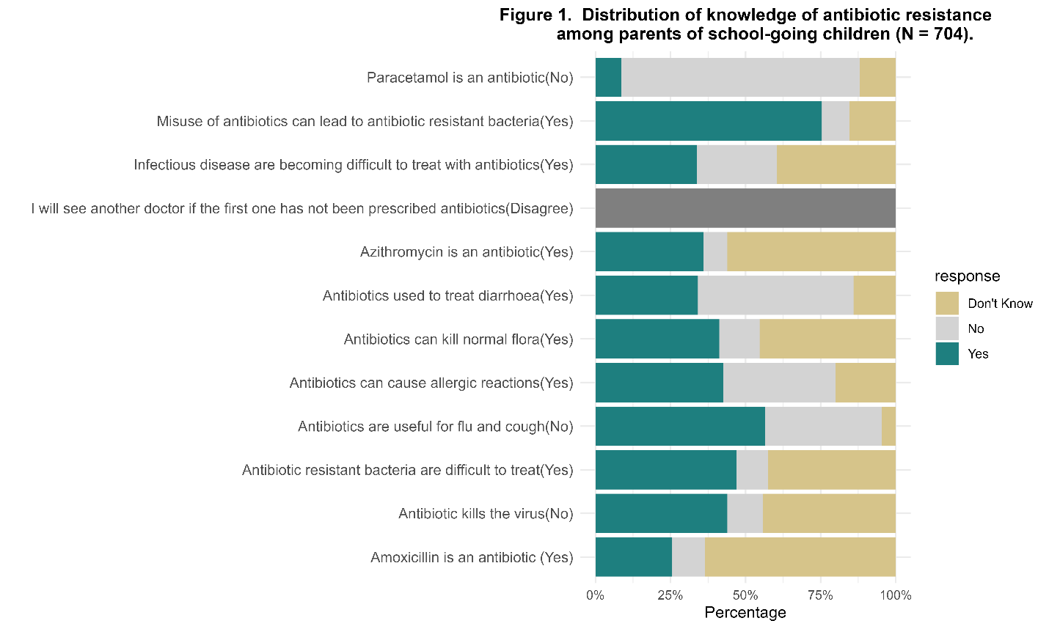

Figure: Figure 1. Distribution of knowledge of antibiotic resistance among parents of school-going children (N = 704)

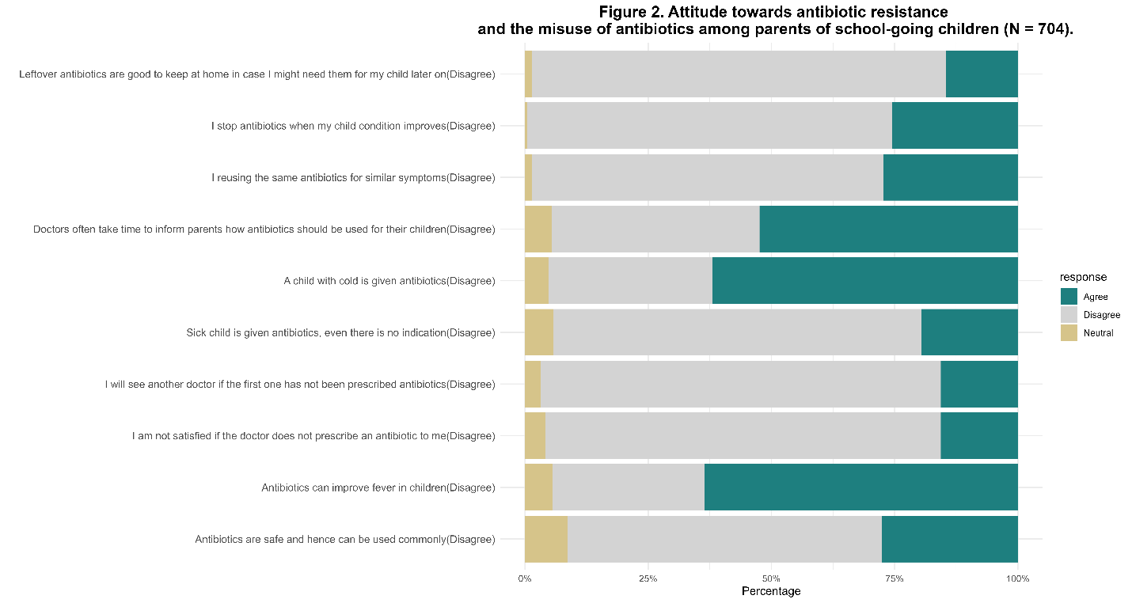

Figure 2. Attitude towards antibiotic resistance and the misuse of antibiotics among parents of school-going children (N = 704).

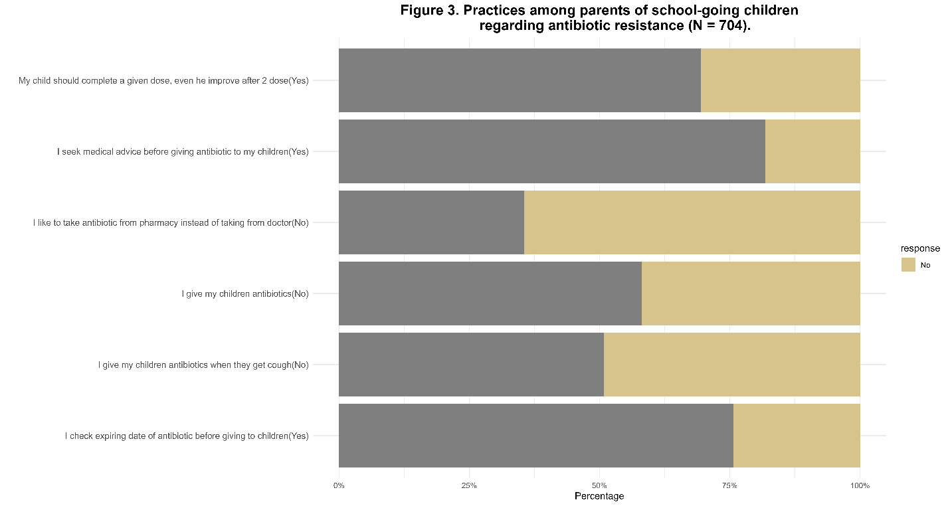

Figure 3. Practices among parents of school-going children regarding antibiotic resistance (N = 704)